|  |
| --- |
| Android Studio Setup Guide |

Contents

**Pre-Installation Preparation** 1

**Installing Android Studio Bundle** 2

**Starting Android Studio for the first time** 7

**Creating your first Android Application** 12

**Creating an Android Virtual Device (AVD)** 17

**Launching an AVD and testing your app** 22

**Appendix 1: Install HAXM for faster loading of x86 Emulator on Intel-chip computers** 27

## **Pre-Installation Preparation**

1. Check that Java Development Kit (JDK) Version 8 and above are installed in your computer.
2. Run **java –version** at the command prompt.

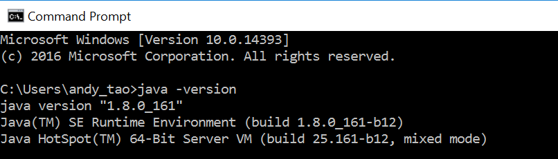

1. If Java is not found, download and install Java at <http://www.oracle.com/technetwork/java/javase/downloads/index.html>
2. Check that you have at least 8GB of free space in your C drive. Otherwise, the installation could not be completed. Move your user data to other drives or run Disk Clean-up to free up more space.

## **Installing Android Studio Bundle**

1. Create a sub-directory, “C346” in D drive root directory (i.e. to create D:\C346)

*This would be the directory to store all the files in this module, including project files, SDKs and Android Studio that you will be installing later in step 2.*

1. Copy the Android Studio installer from your facilitator Thumb Drive or Download Android Studio at <https://developer.android.com/studio/index.html> to your computer.
2. Installing Android Studio
   * Double click on the downloaded file and follow the setup wizard to install it. (You should keep to the default setting, just click on “Next”, “I Agree” or “Install” accordingly. *It might take a few minutes for the installation to be completed. While waiting, you may attempt worksheet section 1.)*
   * If there is any old version Android Studio pre-installed on your laptop, you can choose to uninstall it before moving on. We are installing and will be using Android Studio version 3.3.2 in this module.

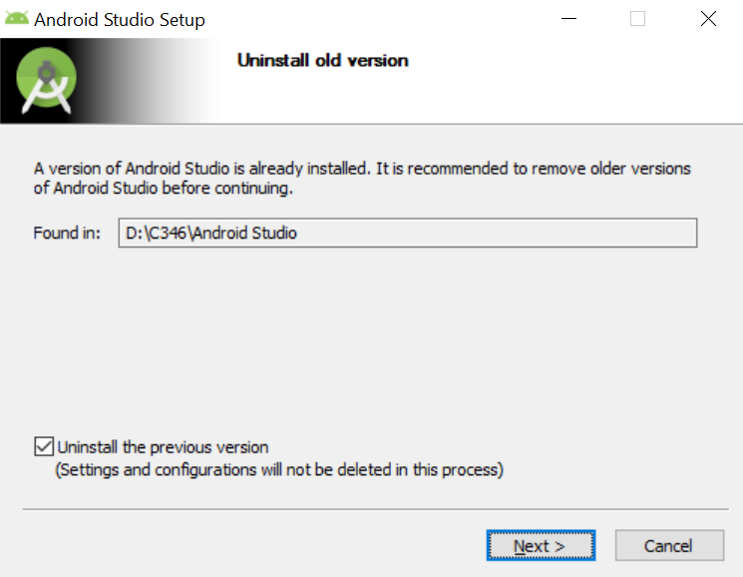

* + Following the steps as per the screen below.

Select all the options and click on **Next**.

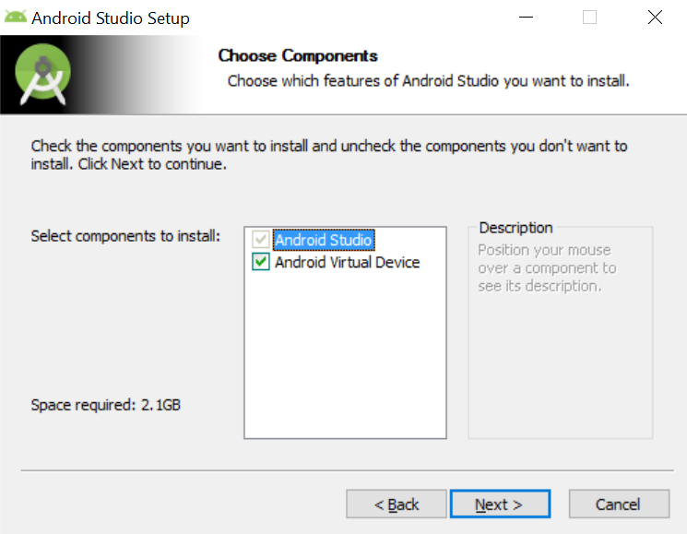

Browse and choose the location below to save your Android Studio.

Click on **Next** after the location has been set properly.

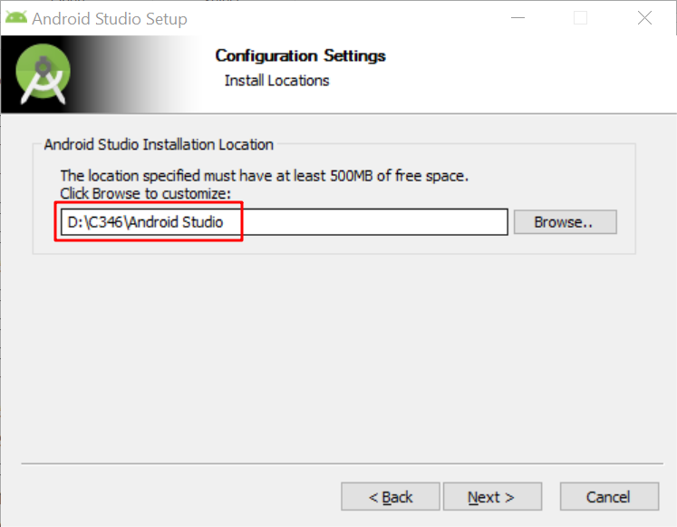

Click **Install**.

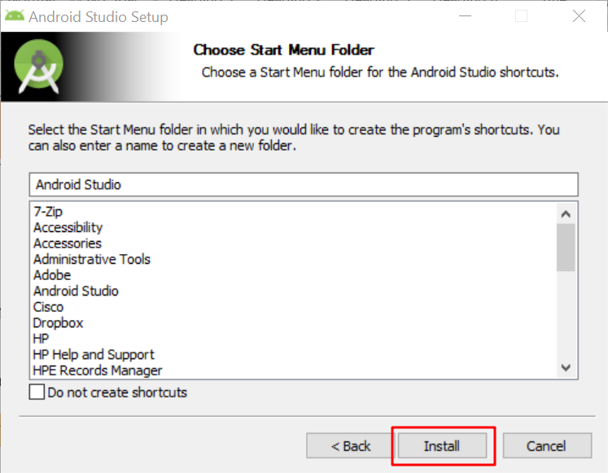

After the setup has completed successfully, you should see the window below. *Notify your facilitator immediately if you could not get this window.*

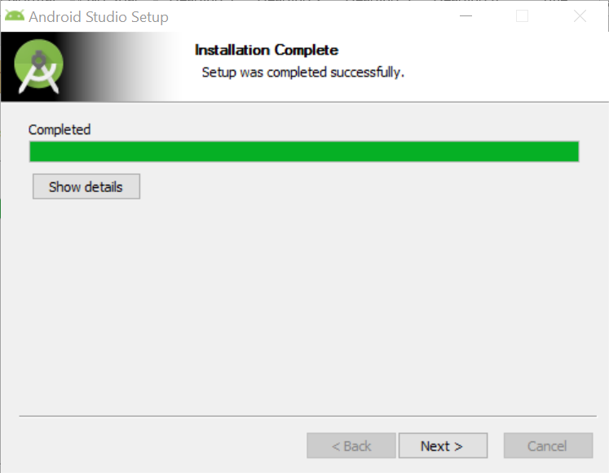

If you see any of the following errors popping up, just click **OK**.

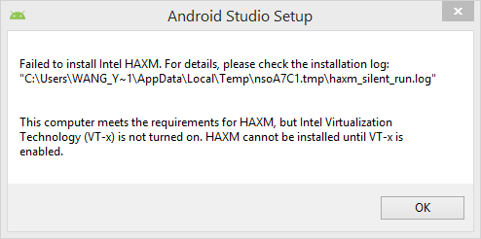

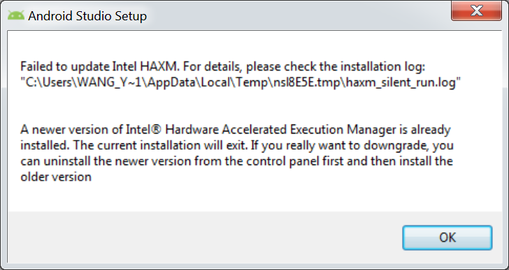

1. Click on **Next** to go to the last window.
2. Leave “Start Android Studio” as checked and click **Finish**.

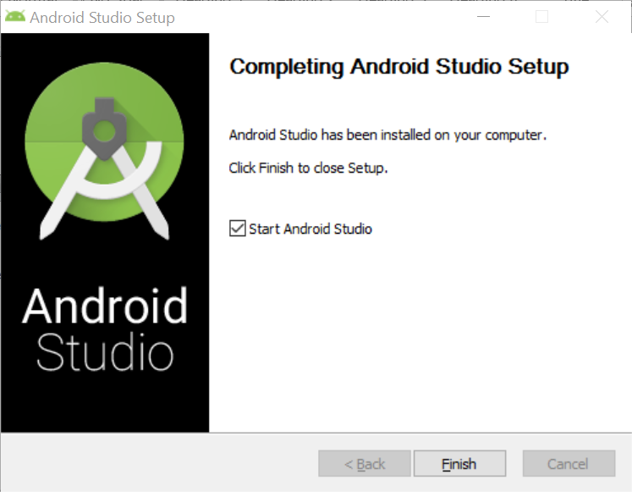

If you see the following window popping up, choose “**Do not import settings”** and click **OK**.

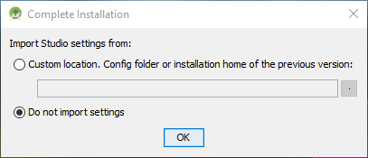

Android Studio will be automatically started after installation.

*Note: If you want to start Android Studio next time, just search “Android Studio” in programs. In fact it is better to create a shortcut on the desktop.*

## **Starting Android Studio for the first time**

When Android Studio is starting for the first time, it will download the necessary components automatically from the internet. You will need to wait for this process to be completed.

Depending on the speed of the internet, it may take up to a few ten minutes to a few hours to install it.

Click **Next** to start and follow the steps.

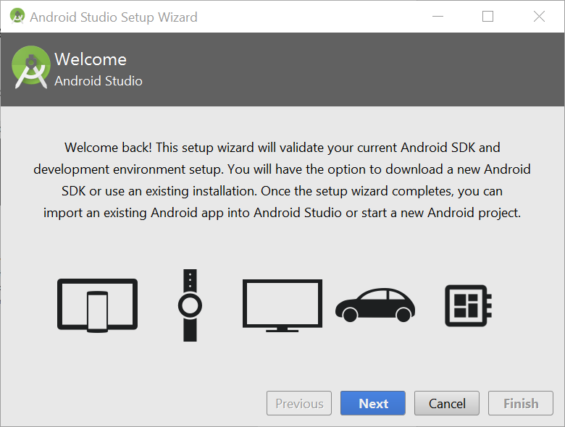

Choose **Custom** and click on **Next**.

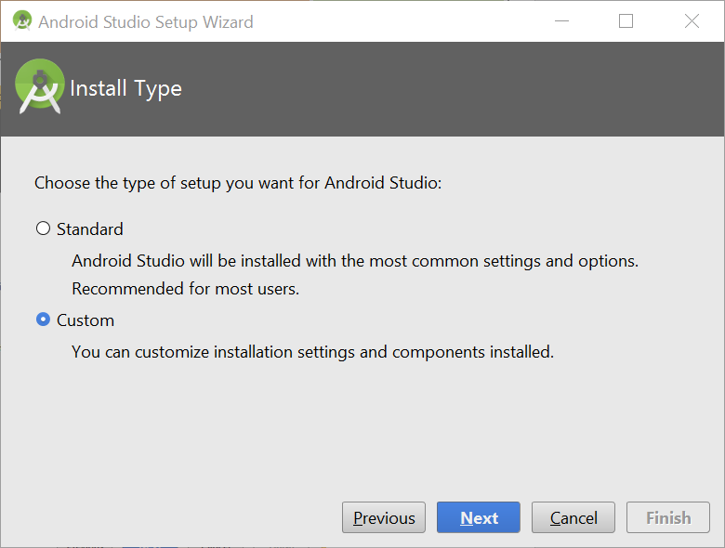

Choose a theme based on your preference, and click on **Next**.

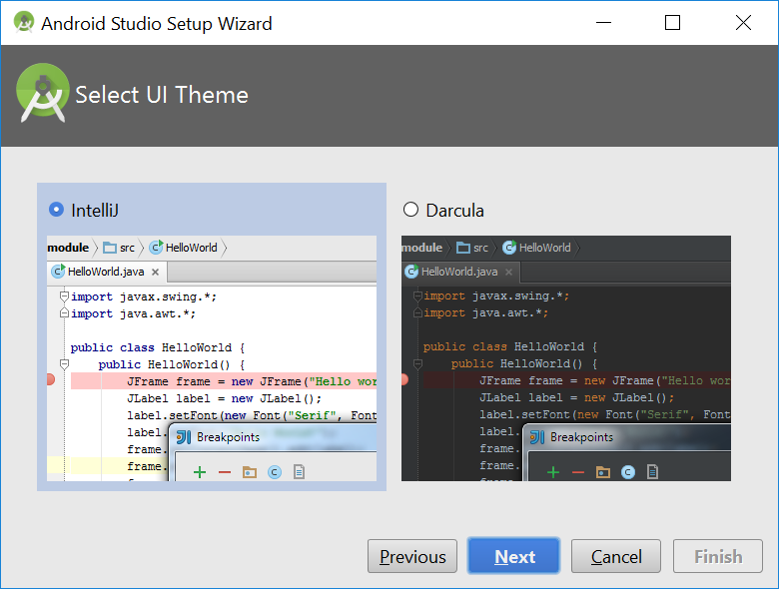

Leave **“Android SDK”, “Android SDK Platform”** and **“API 28”** as selected.

Select **“Performance (Intel HAXM)”.**

Browse and choose the location as below to save your SDK.

Click on **Next**. **IMPORTANT: please check you have set the configurations above properly before clicking the Next button.**

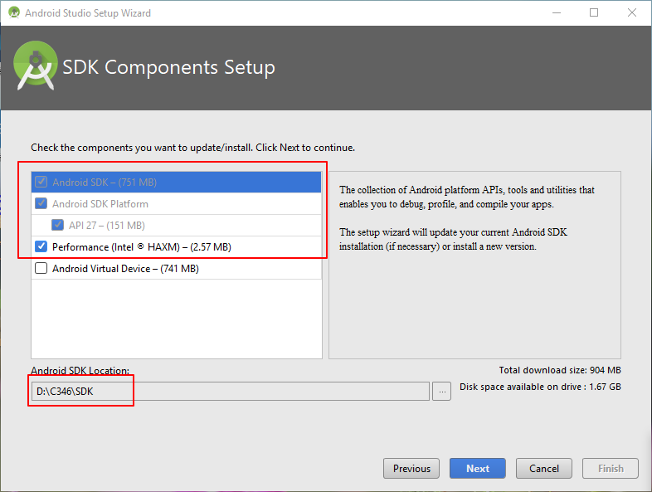

Leave the setting as recommended and click on **Next**.

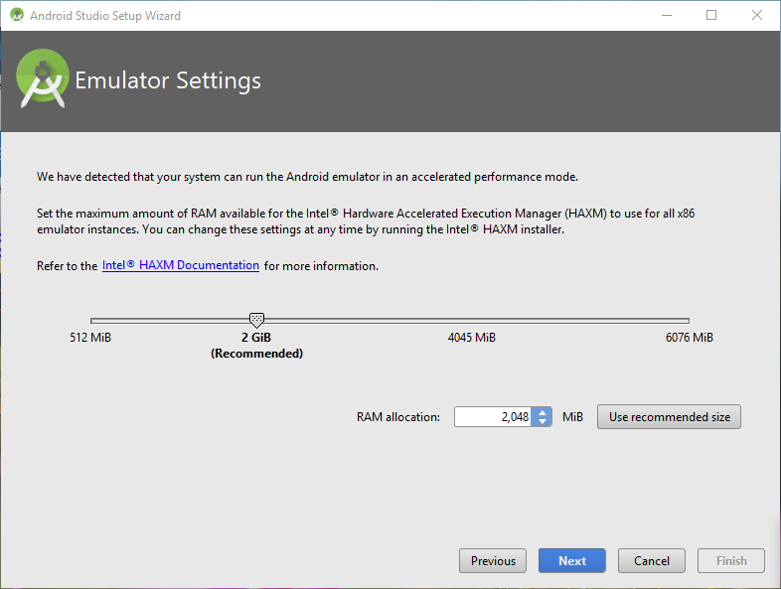

Click **Finish** to start downloading. Be patient. This may take a long time. You can attempt the worksheet section 1 during waiting.

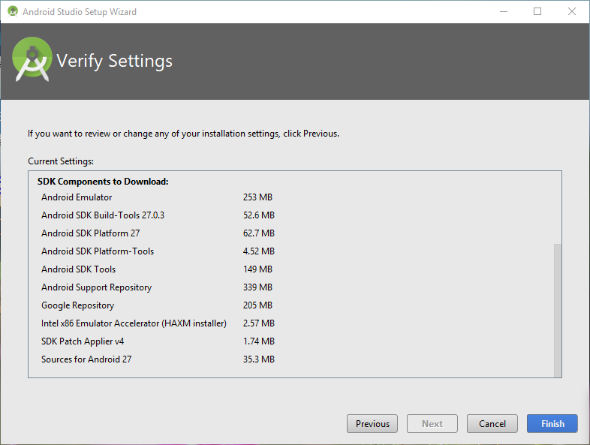

After the download and installation are completed, you should see the screenshot below. Click **Finish** to continue.

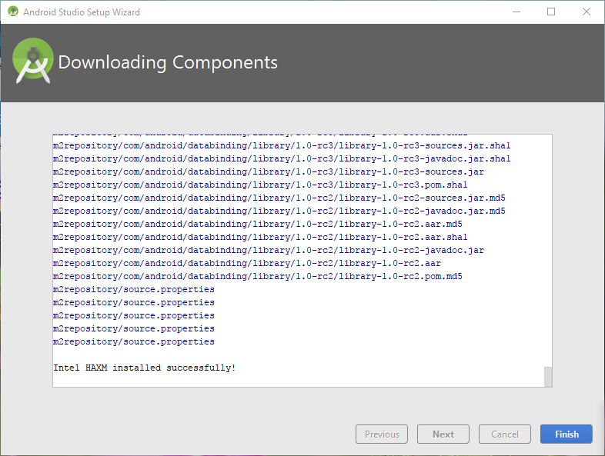

## **Creating your first Android Application**

1. Choose **“Start a new Android Studio project”**.

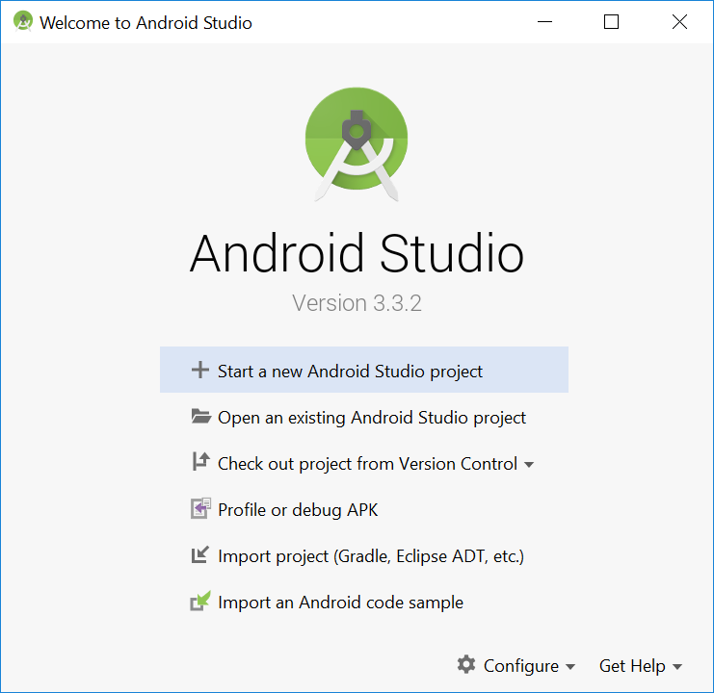

1. Choose **Empty** Activity, and click on **Next**.

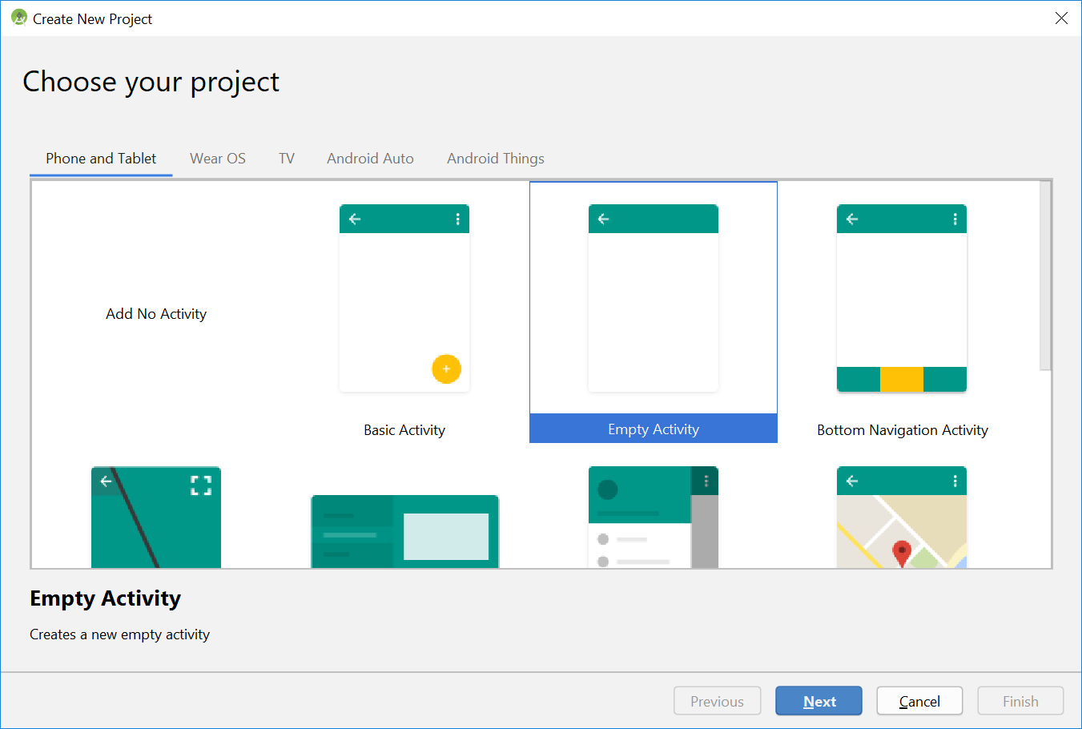

1. Fill in the project details as below, and click on **Next**.
   * Application Name: My First App
   * Package Name: sg.edu.rp.c346.myfirstapp
   * Project Location: D:/C346/Workspace/P01/MyFirstApp
   * Change Minimum SDK to **“API 16: Android 4.1 (Jelly Bean)”**
   * Click **Finish** to complete the creation of a project.

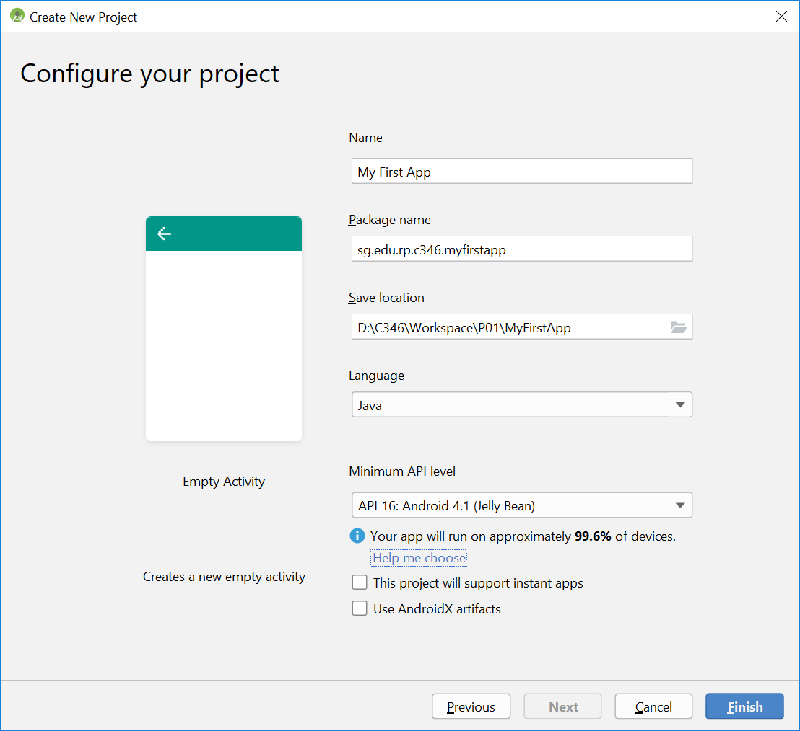

1. The first build will take some time. Be patient. When you see the page below or the main start-up page, it means that you have successfully created a new project.

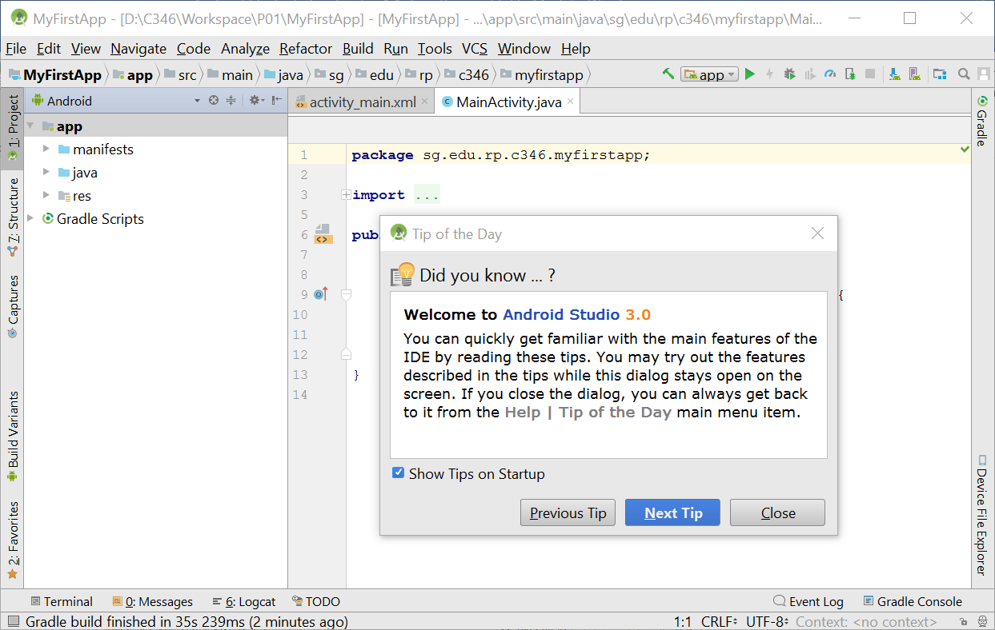

1. If you encounter the Gradle error as below, try to click on the link and follow the steps to perform the quick fix. Android Studio should download the necessary component and fix the issue.

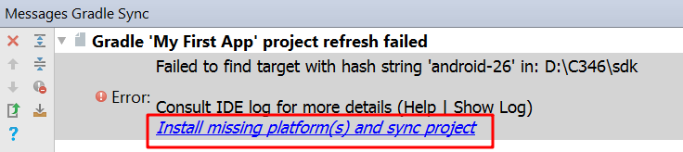

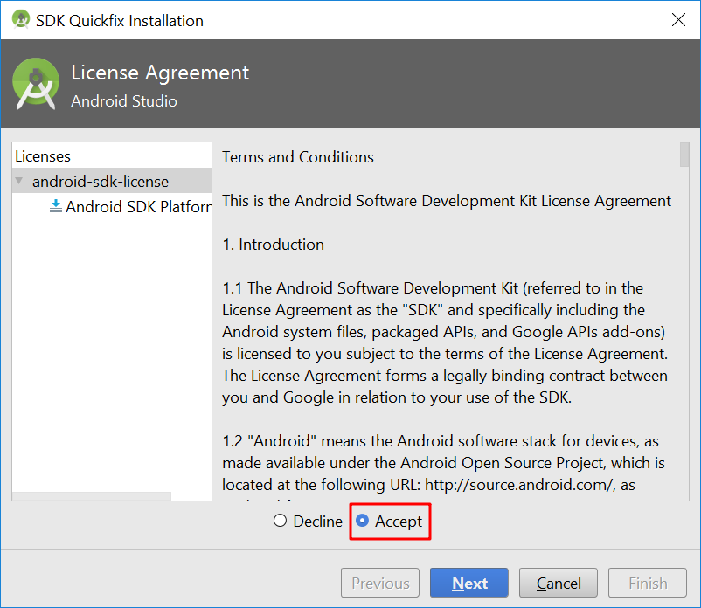

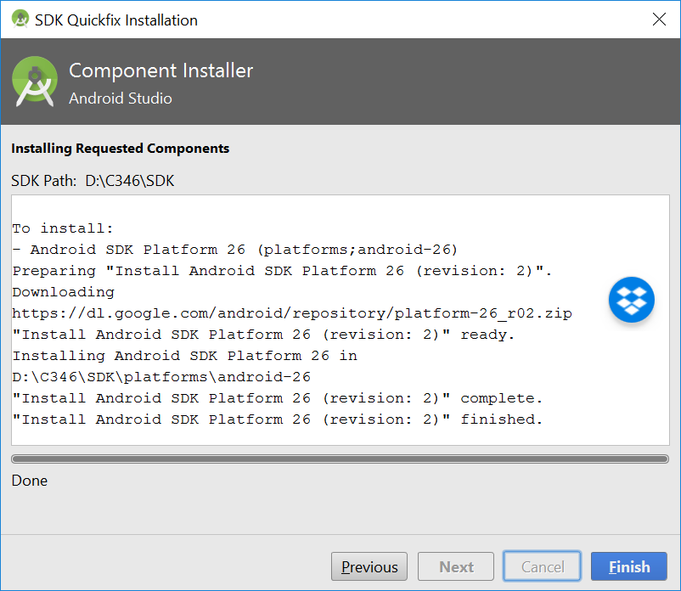

## **Creating an Android Virtual Device (AVD)**

Before you can run any Android Studio Project, you need to create an Android Virtual Device (AVD) first.

1. Click on the AVD Manager icon on the Toolbar.

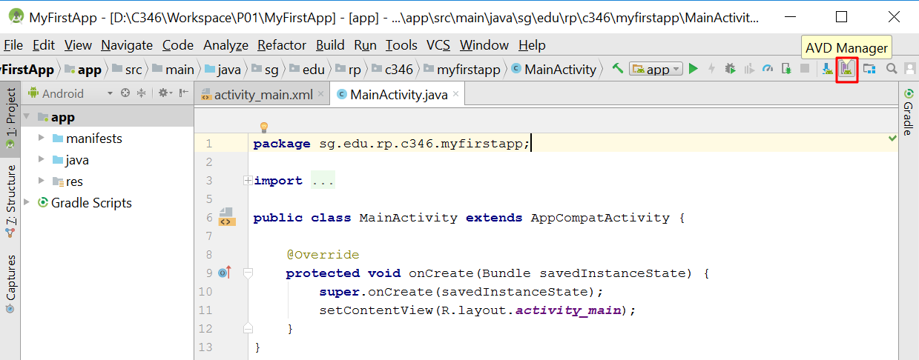

1. Right click on each row (if any), and choose **Delete** to remove any existing virtual device.

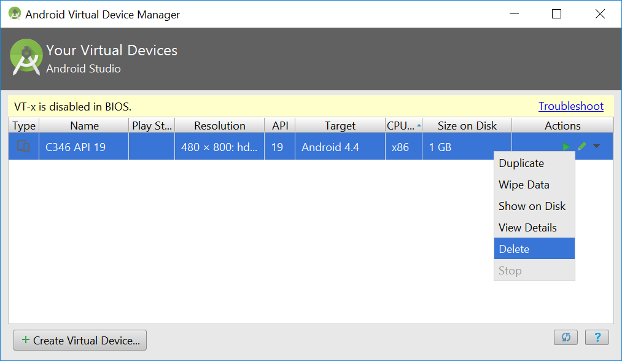

1. Click on the **“Create Virtual Device”** to create a new virtual device.

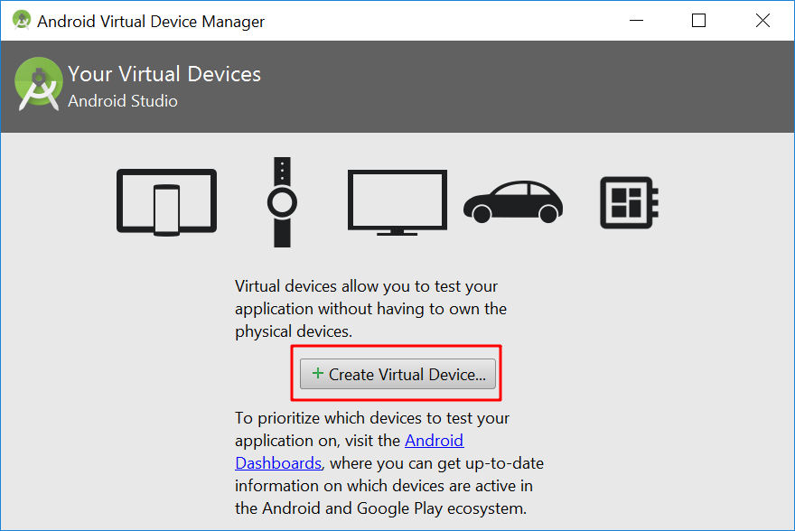

1. In Phone Category choose **Pixel**, and click on **Next**.

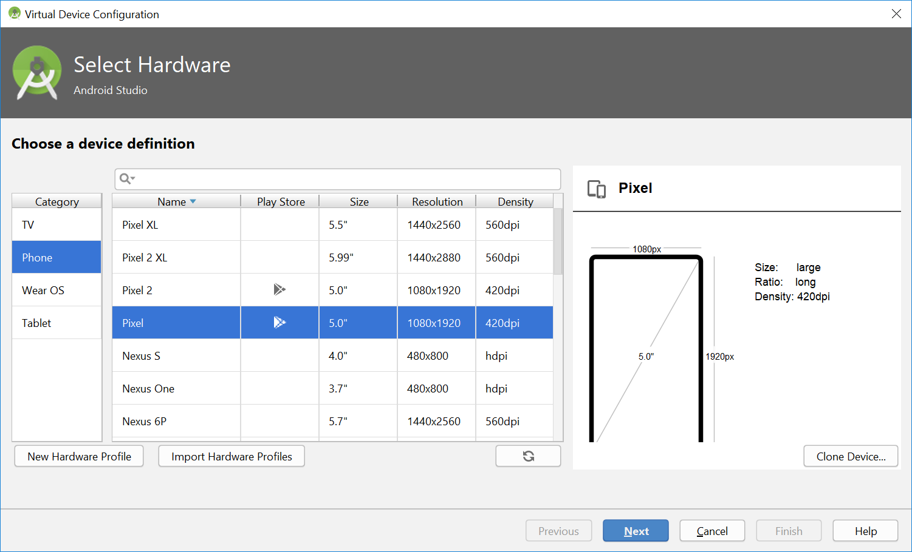

1. Select a System Image. Under **Recommended** tab, download ***API Level 28*** by clicking on the **Download** link.

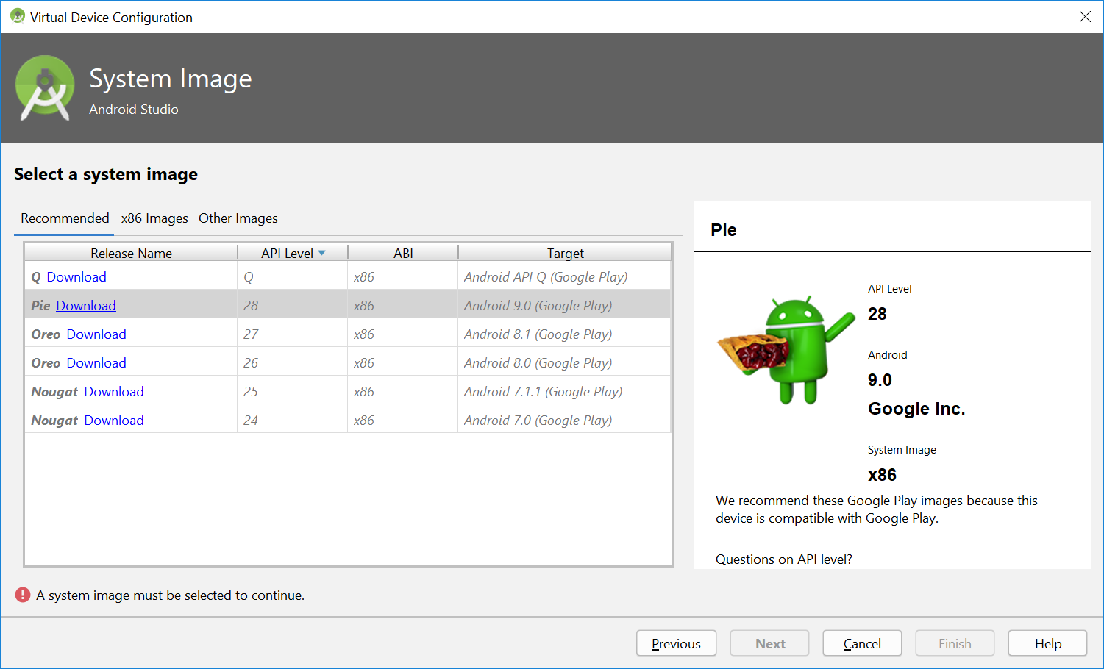

1. Wait for the installation to complete and click **Finish**. This may take some time.

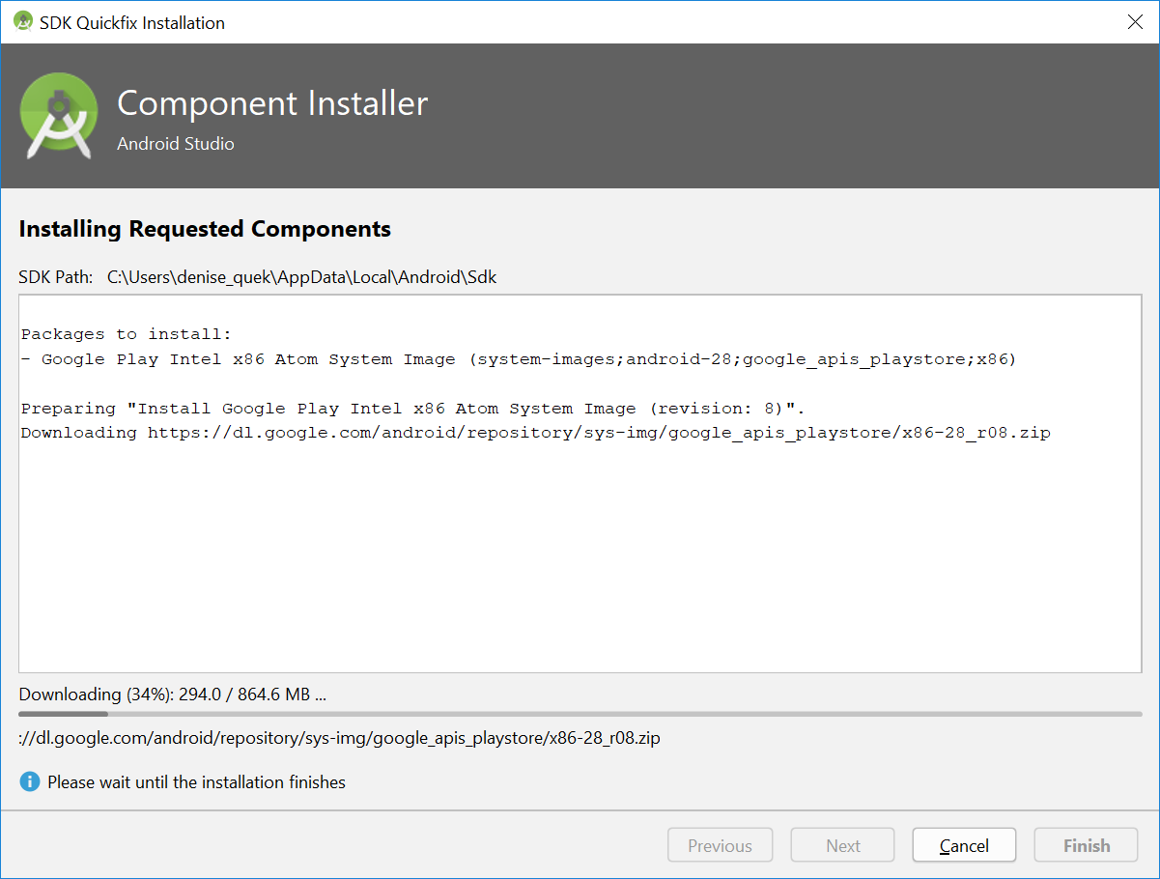

1. Now the image has been downloaded. Choose ***API Level 28*** and click on **Next**.

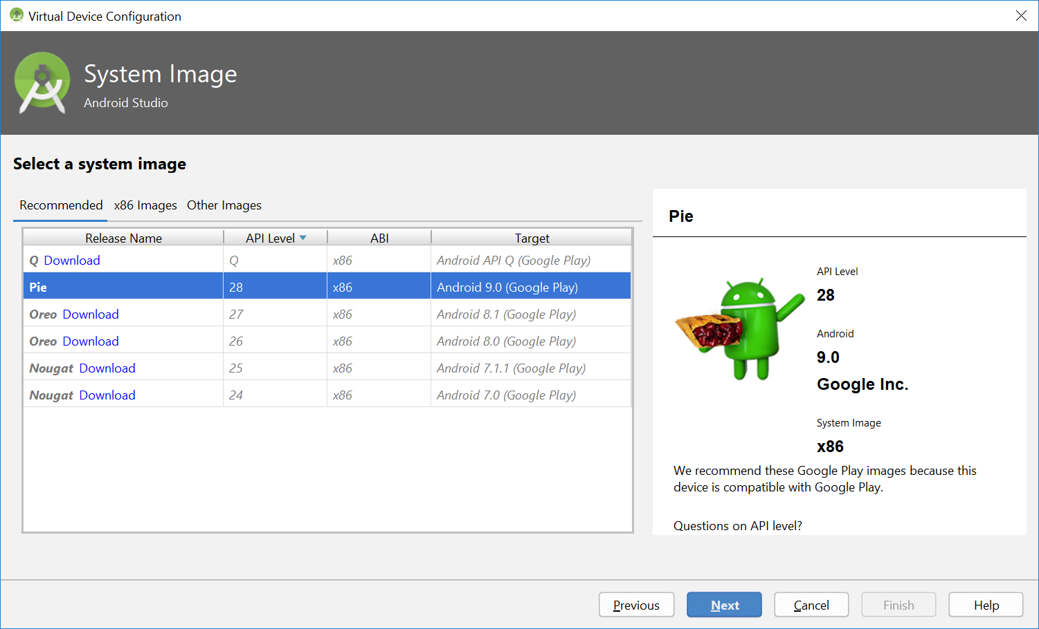

1. Change the AVD name to **C346 API 28**. Leave all other settings unchanged and click **Finish**.

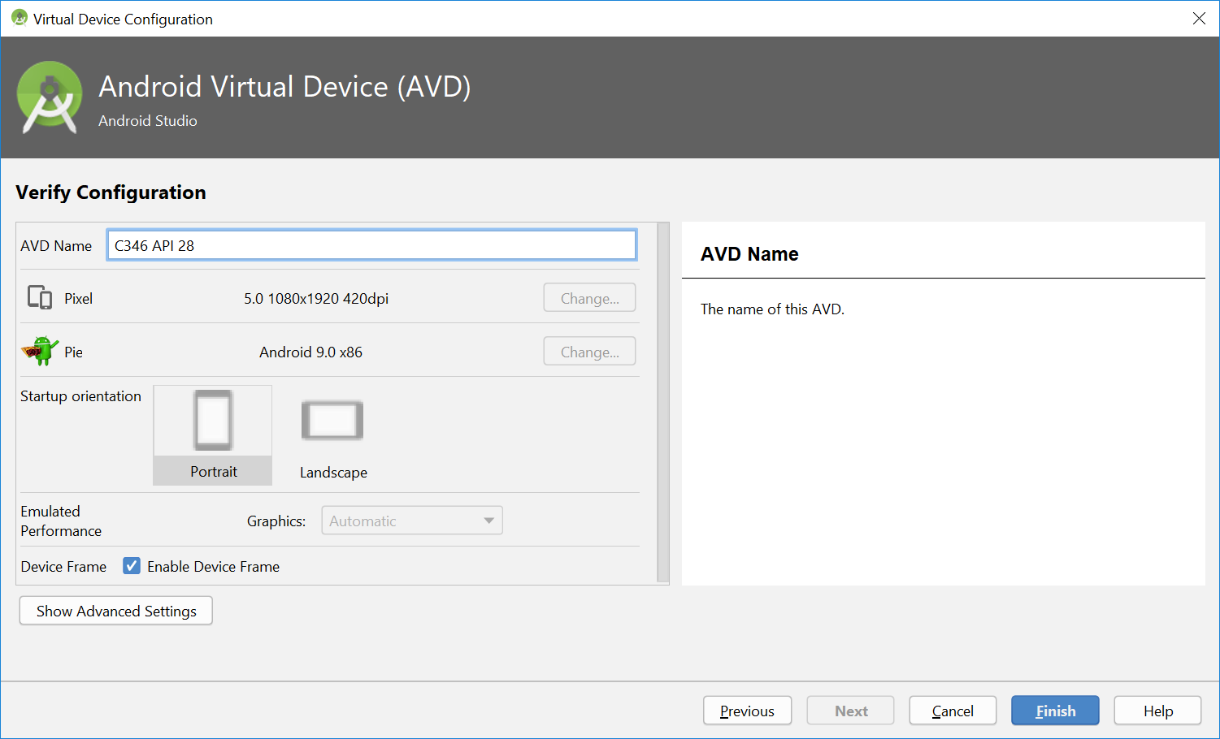

1. Now you should see only one virtual device created.

Congratulation! You have completed the tasks for this section.

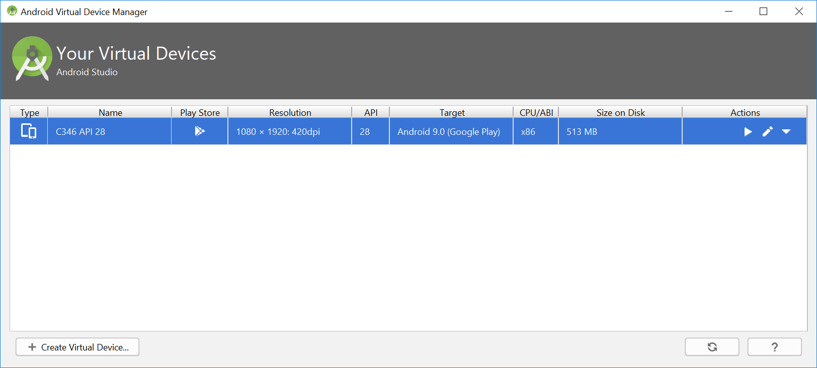

## **Launching an AVD and testing your app**

1. Now let’s start our virtual device. Click on the green play button to launch the AVD.



1. Wait for the AVD to launch successfully, you should see the following phone window.

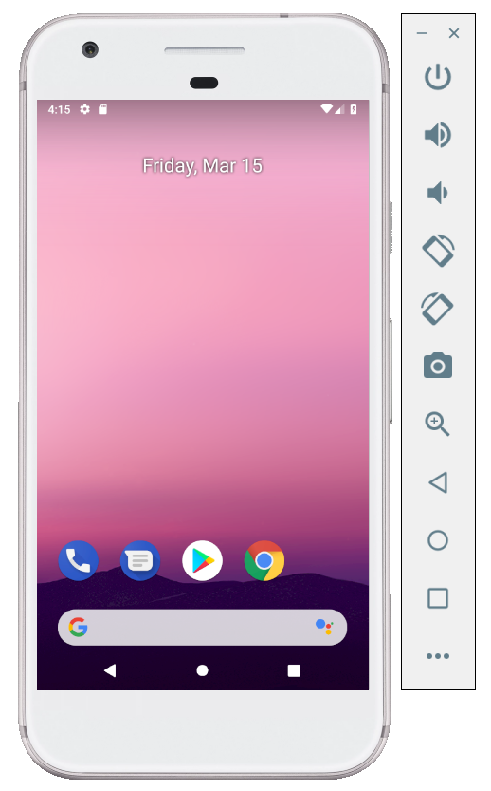

*Note: If you hit the following error, you would need to enable VT-x in BIOS or alternatively, create another emulator with ARM CPU setting.*

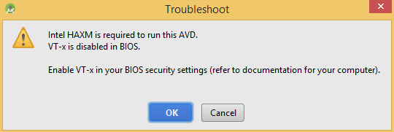

|  |
| --- |
| *How to enable VT-x in BIOS?* |
| Refer to this link:  <https://www.youtube.com/watch?v=vP71TkSh67M> |

|  |
| --- |
| *How to create emulator with ARM CPU setting?* |
| The steps are generally the same as what we did in last section. Just when selecting the system image, choose from “Other Images” instead of the other two tabs. |

1. Now you can test your Android project on this Virtual device. Switch to the Android Studio Interface, and click on the green play button on the taskbar to run the app.

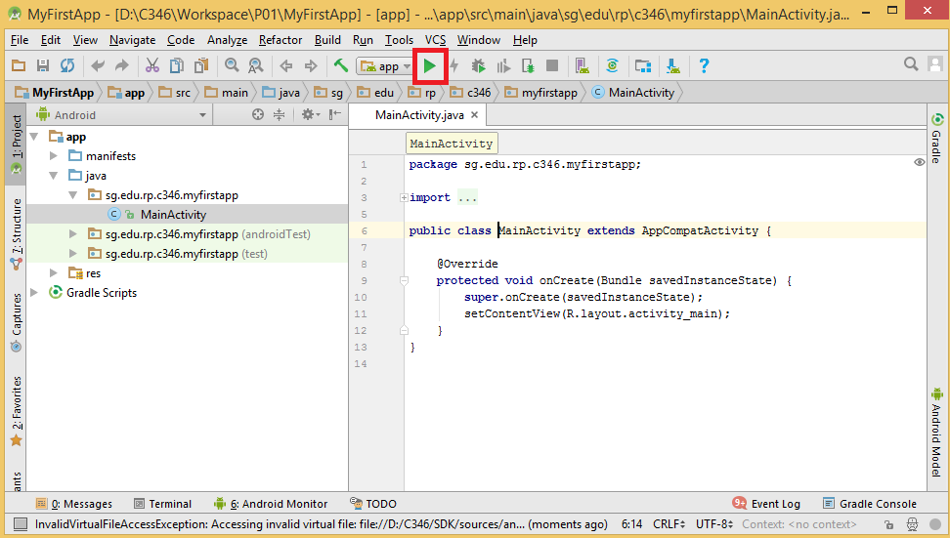

1. It will load all the available devices, choose the one shown (C346 API 28 Emulator) and click **OK**.

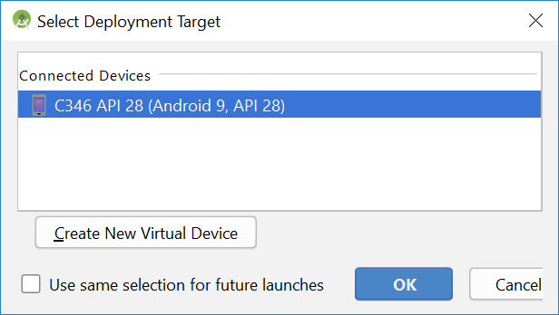

1. You should see your first “Hello World” app appearing on the emulator you launched earlier. Congratulation! You have successfully run your first App on the virtual device.

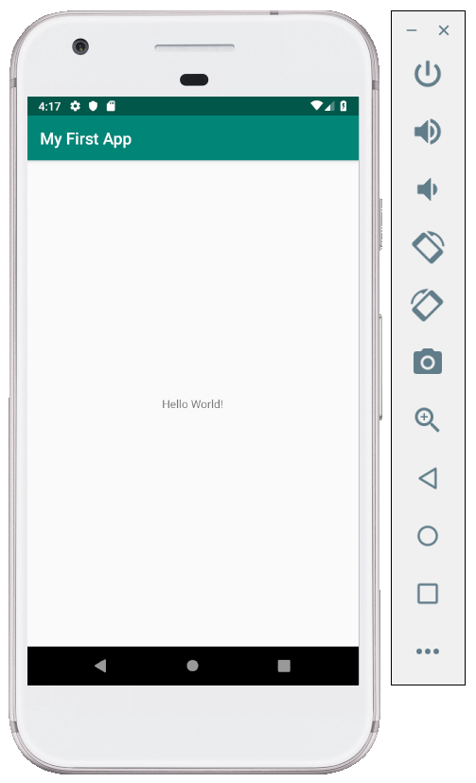

**Important Note:**

*In future lessons, do not perform the update action if there is a message popping up on starting Android Studio.*

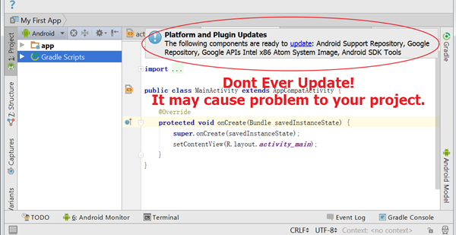

*Since you will be using Android Studio weekly, it is better to create a way to access it easily. One way is to pin it to the taskbar. Alternatively, you can also create a shortcut for Android Studio on your desktop.*

*Go to the link below to learn how to do it.*

<https://support.microsoft.com/en-us/help/15059/windows-8-pin-apps-folders-desktop-taskbar>

**Now, you can proceed with worksheet section 2.**

## **Appendix 1: Install HAXM for faster loading of x86 Emulator on Intel-chip computers**

1. Open up the **SDK manager**, click on the **SDK Tools** tab, and scroll down to the **Intel x86 Emulator Accelerator (HAXM installer)**. Tick the box in front if it is unchecked, and click **OK**.

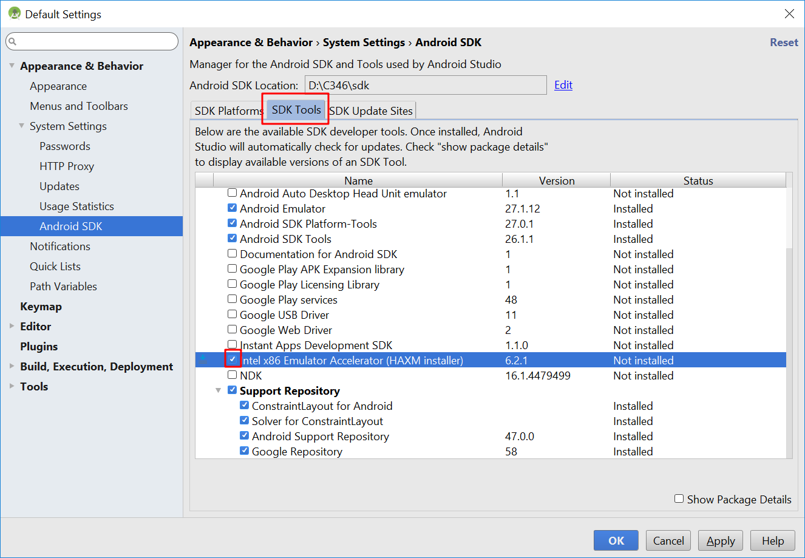

1. Click on **Apply** and then **OK** to confirm the installation. After the installation, click **Finish**. You may realize that your emulator now loads faster than before.

